Description on how to download EOD data from BigCharts using Yahoo symbols:

Daily stock quotes for many countries can be downloaded from BigCharts. For example,
daily data on a specific date for symbol AU:GSW (GetSwift Ltd.) is available on this URL:

http://bigcharts.marketwatch.com/historical/default.asp?detect=1&symb=AU:GSW&closeDate=02/28/2018

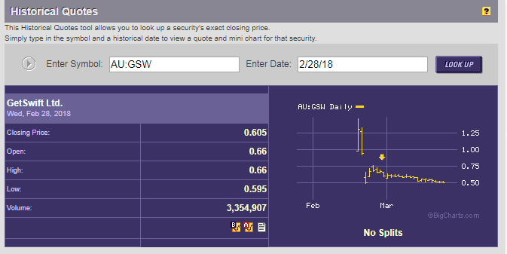

To get historical daily data for AU:GSW, we will need HSQuote Plus to step through each date for the download period to get one day data at a time. The following set up will automate the process.

In addition, if we want to use Yahoo symbols to fetch data from BigCharts, while Yahoo symbols use different convention (GSW.AX), we will need to provide the country exchange code (AU in this case) in the portfolio name.

Set-up:

- Copy the following lines and append to your existing “mywebserver.txt”, or simply substitute it the attached “mywebserver.txt”.

BC_Yahoo_D_XXXX,http://bigcharts.marketwatch.com/historical/default.asp?detect=1&symb=SSSS&closeDate=MM1M/DDDD/YY4Y,D2,BigCharts_Yahoo_D2.fmt

- Copy the “BigCharts_Yahoo_D2.fmt” file to the “fmt” subfolder.
- Run HSQuote Plus and set up “BC_Yahoo_D_AU.tic” as shown.

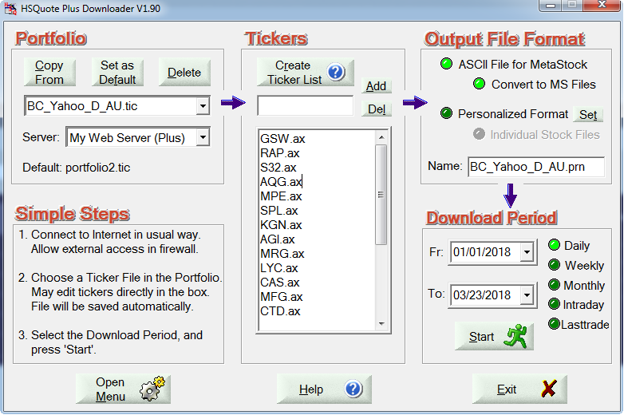

Historical Daily Data Download:

Specify the Download Period as usual. The download will step through one day at a time, as shown.
